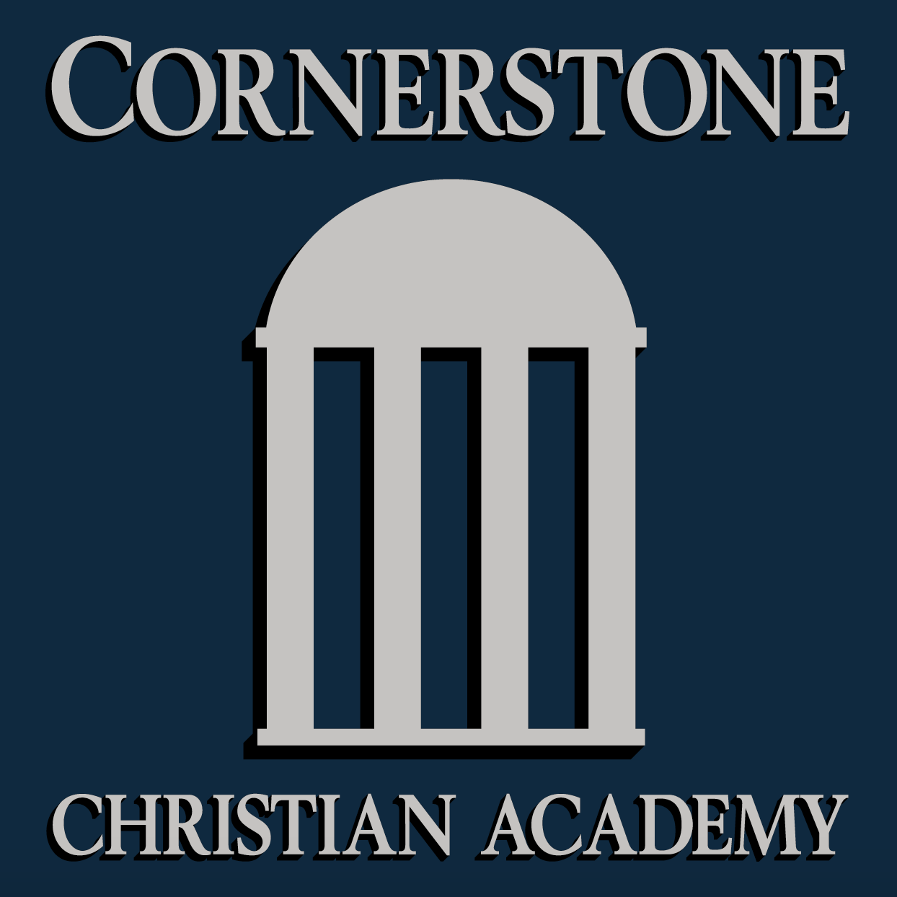
Office use only

- Date appt received______________
- Reg. Fee received_____________
- Interview date_________________
- Accepted_______Denied________

Application

For admission to

Cornerstone Christian Academy

169 Police Tower Road

P.O. Box 897
Appomattox, VA 24522
(434) 352-2345 ccaofva.org

Name of student __________________________________________ Male ____ Female ___
Date of birth _____/_____/_____ Grade entering ___________ Race _________________

Name of student ___________________________________________ Male ____ Female ____
Date of birth _____/_____/_____ Grade entering ___________ Race _________________

Name of student ___________________________________________ Male ____ Female ____
Date of birth _____/_____/_____ Grade entering ___________ Race _________________

Name of student ___________________________________________ Male ____ Female ____
Date of birth _____/_____/_____ Grade entering ___________ Race _________________

Residence address ____________________________________________________________
City/State/Zip _________________________________________________________________

Father’s name ________________________________ Home Phone_____________________
Home address ________________________________ Work Phone _____________________
Cell Phone ______________________
E-mail __________________________
Place of employment ___________________________ Position ________________________

Mother’s name ________________________________ Home Phone_____________________
Home address _________________________________Work Phone _____________________
Cell Phone ______________________
Email __________________________
Place of employment ___________________________ Position ________________________

Guardian’s name ______________________________ Home Phone_____________________
Home address ________________________________ Work Phone _____________________
Cell Phone ______________________
E-mail __________________________
Place of employment ___________________________ Position ________________________

- Cornerstone Christian Academy is a Christian School. Do you agree to have your student taught in accordance with the “Statement of Faith”? (See page 6) _______________________________________

- How did you hear about Cornerstone Christian Academy? ______________________________________________________________________________________________________________________________________________

- Why do you want your student to attend CCA?
______________________________________________________________________
______________________________________________________________________

- How do you think parents should participate in the education of their children?
______________________________________________________________________
______________________________________________________________________

- Are parents, stepparents or guardian(s) opposed to a Christian education?
____________________
(We do not require that you be Christian, but it should be understood that your
child will receive a Christian education.)

- Family’s church _____________________________ Pastor ______________________

7. CCA is greatly helped by parents who regularly and enthusiastically serve as
volunteers. Please list any skills that could be of assistance.
ڤ Library ڤ Coaching ڤ Art ڤ Music ڤ Other Skills (please name) __________

- Please list the school last attended or presently attending.

  - Name of student _______________ Teacher’s name ______________________
School name ______________________________ Phone _________________
School address ____________________________________________________

b. Name of student _______________ Teacher’s name ______________________
School name _______________________________ Phone ________________
School address ____________________________________________________

c. Name of student _______________ Teacher’s name ______________________
School name _______________________________ Phone ________________
School address ____________________________________________________

d. Name of student _______________ Teacher’s name ______________________
School name _______________________________ Phone ________________
School address ____________________________________________________

- Cornerstone Christian Academy is not staffed to handle students with severe
learning disabilities or behavioral problems. For your student’s best interest, please
be candid when you answer the following questions. (If more than one student is
applying, please consider each student when answering.) Further elaboration on
your answers may take place during an interview.

a. Has the student ever been referred for testing or placed in a special program?
Yes ڤ No ڤ

b. Has the student received any other special help or tutoring? Yes ڤ No ڤ

c. Has the student ever repeated a grade for any reason? Yes ڤ No ڤ

d. Has the student received any special honors or awards for scholastic achievement?
Yes ڤ No ڤ

e. Has the student ever been suspended (in school detention or out of school
suspension) or expelled by a previous school? Yes ڤ No ڤ

f. Has the student ever seen a counselor/doctor/psychiatrist for any type of social,
behavioral, or mental problems? Yes ڤ No ڤ
If so, briefly describe the nature of the problem. ______________________________
_____________________________________________________________________

g. Has the student ever been examined or treated by a counselor/doctor/psychiatrist
for hyperactivity or attention deficit disorder (ADD or ADHD)? Yes ڤ No ڤ

h. Do you suspect or have you been told that your student might have dyslexia?
Yes ڤ No ڤ

i. Has your student ever been involved in legal problems or been arrested?
Yes ڤ No ڤ

- Please check any of the following causes of stress that have occurred in your
student’s current or former home environment.

ڤ Change of school  ڤ Frequent moves  ڤ Job changes  ڤ Death in family  ڤ Separation/divorce of parents  ڤ Alcohol/substance abuse | ڤ Separation from significant non-family member  ڤ Separation from significant family member  ڤ Physical illness in the family  ڤ Mental illness in the family  ڤ Prolonged hospitalization of family member  ڤ Other (please specify)

If you have more than one student applying to CCA, please indicate the child’s name in your responses.

11. Does your student(s) have any ongoing health problems?
Yes ڤ No ڤ Yes ڤ No ڤ Yes ڤ No ڤ Yes ڤ No ڤ
If yes, please explain ___________________________________________________________
____________________________________________________________________________

12. List any medications your student regularly takes.
____________________________________________________________________________
____________________________________________________________________________

13. Has your student had problems with any of the following?
ڤ Ear infections | ڤ Frequent sore throat
ڤ Head injury | ڤ Allergies
ڤ Loss of consciousnes | ڤ Visual problems
ڤ High fevers | ڤ Convulsions/seizures
ڤ Asthma | ڤ Other (please list)
ڤ Difficulty sleeping | ____________________________
 | ____________________________
14. What do you view as your student’s educational strengths and weaknesses?
____________________________________________________________________________
____________________________________________________________________________
____________________________________________________________________________
____________________________________________________________________________

15. What kinds of teaching methods seem to work best for your student?
____________________________________________________________________________
____________________________________________________________________________
____________________________________________________________________________

16. What form of discipline is most effective with your student?
____________________________________________________________________________
____________________________________________________________________________
____________________________________________________________________________

17. How does your student usually respond to discipline?
____________________________________________________________________________
____________________________________________________________________________
____________________________________________________________________________

18. What are your student’s hobbies and main interests?
____________________________________________________________________________
____________________________________________________________________________

19. How would you characterize your child’s attitude towards school and learning?
________________________________________________________________________________________________________________________________________________________

To complete the application process, please include the following:

  - A $125 registration fee per new student – up to $250/family regardless of number of students. This fee will be refunded only if the student is not accepted by Cornerstone Christian Academy.
  - Report card from the most recent six or nine weeks and one from the previous year, if applicable.

In addition, for upper school students in grades 6-12, please include a statement by the student explaining why he/she would like to attend Cornerstone Christian Academy.

After the school receives the completed application and other required materials, we will contact you to arrange an interview. CCA will also arrange a time for your student to take an assessment test.

Parental signature

I certify that this application is correct and complete.

_______________________________________________ _____________
Parent (Guardian) signature Date

_______________________________________________
Parent (Guardian) name printed

MISSION STATEMENT

The mission of Cornerstone Christian Academy is to assist parents in our community in the Christian nurture and education of their children by providing a Christian school in the classical tradition of excellence. This education is Christ-centered and classical in content, approach, and philosophy. Emphasis is placed upon teaching students how to think and how to learn. The CCA curriculum and educational methodology are designed to meet the spiritual, academic, social, and cultural needs of the Christian student.

STATEMENT OF FAITH

Our school statement of faith highlights key points of our standards.

- Holy Scriptures (the Old and New Testament) contain all things necessary to Salvation, so that whatever is not found in the Scriptures, nor proved thereby, no one shall be required to believe as an article of faith.

- There is but one living and true God, of infinite power, wisdom, and goodness. In the unity of this Godhead there are three persons, of one substance, power, and eternity; the Father, the Son, and the Holy Ghost.

- The Son, of one substance with the Father, took Man’s nature in the womb of the blessed virgin, so that two whole and perfect Natures, the Godhead and Manhood, were joined in the one person, Jesus Christ, never to be divided. In his Manhood, Jesus Christ is like unto us in all things, except sin only, from which he is clearly void. This same Christ, very God and very Man, truly suffered and was crucified, dead, and buried, to reconcile his Father to us, and to be a sacrifice, not only for original sin, but also for the actual sins of men.

- Christ did truly rise from death, and took again his body, and ascended into heaven, from whence he will return to judge all men at the last day.

- We are accounted righteous before God only for the merit of our Lord and Savior Jesus Christ by faith, and not for our own works or deserving. Wherefore, we are justified by faith only, as the Scripture teaches.

- Good works, however, spring necessarily out of a true and lively faith, insomuch as by them a lively faith may be known.

- The visible Church of Christ is a congregation of faithful people, in which the pure Word of God is preached, and the sacraments (Baptism and the Lord’s Supper) be duly ministered according to Christ’s Ordinance.

- The Church has power to decree ceremonies and rites, and authority in controversies of the faith; and yet it is not lawful for the Church to ordain anything contrary to God’s written Word. Neither may the Church expound one place of Scripture in repugnance to another. Wherefore, although the Church is the Witness and Keeper of God’s Holy Word, yet ought not to decree anything against the same.

